Chapter 21 – Origins of Modern Astronomy

Motions of the Earth-Moon System (p. 617–620)
A. Introduction
1. Approximately how long does it take the moon to complete one full orbit around the earth?

2. Which way does the moon revolve around the earth?

B. Phases of the Moon
Definitions: The following terms define the various phases of the moon. Memorize these terms!
Full Moon | The moon is full when the side we see is 100% illuminated. A full moon looks like a perfect circle.
New Moon | The moon is new when the side we see is dark. We cannot see a new moon at all.
Crescent Moon | A crescent moon is shaped like a crescent; a smaller proportion of the moon is illuminated than is the case during a quarter moon.
Quarter Moon | The moon is called a quarter moon when it looks like a half circle
Gibbous Moon | A gibbous moon is shaped like a lopsided football; a larger proportion of the moon is illuminated than is the case during a quarter moon.
Waxing Moon | The moon is waxing when the illuminated portion of the moon is getting a little bit bigger every day.
Waning Moon | The moon is waning when the illuminated portion of the moon is getting a little bit smaller every day.
1. Questions About These Definitions: To find the answers to the questions below, consult your data from the moon project, the section in the textbook entitled Phases of the Moon (p. 618–619), and Figure 21.27 on p. 618.
a. How does a 1st quarter moon look different from a 3rd quarter moon? (Hint: think about whether they are lit on the right or left side)

b. How does a waxing crescent moon look different from a waning crescent moon?

c. How does a waxing gibbous moon look different from a waning gibbous moon?

2. The cause of the moon's phases:
a. Where does the moon get its light from?
b. What proportion of the moon is illuminated at any time?
c. What phase is the moon in when it lies between the Sun and Earth? Why?

d. What phase is the moon in when the earth lies between it and the sun? Why?

C. Lunar Motions (p. 617–618)
In addition to reading the text, carefully study the diagram on the next page--ignore Figure 21.26 on p. 617; it is VERY POORLY designed because it implies that the “distant star” is actually so close that it is inside of our solar system. I don’t think so!
1. Synodic Month: How long does it take the Moon to go through all of its phases?

2. Sidereal Month: How long does it take the Moon to complete one 360° revolution around Earth?

3. Why is a synodic month longer than a sidereal month? In answering this question, add to the diagram below.
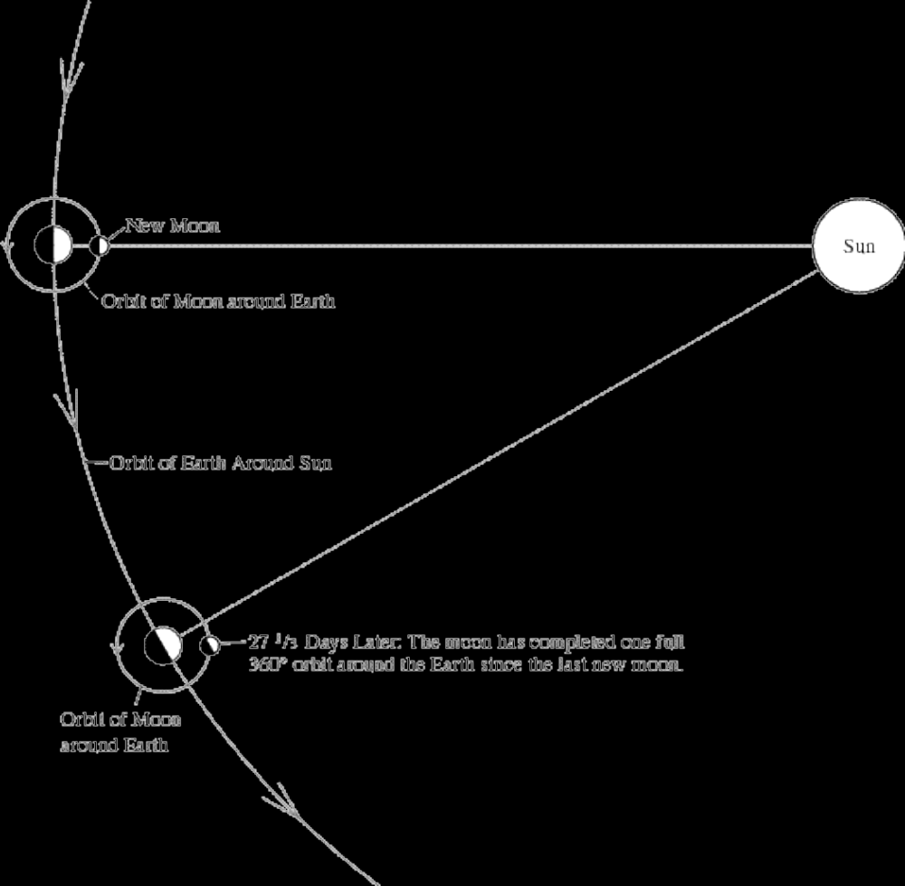

4. Why do we always see the same side of the moon, no matter what phase it is in?

5. How long does daylight last on the moon?
6. How long does darkness last on the moon?
D. Eclipses of the Sun and Moon (p. 619–620)
1. What causes a solar eclipse? (See Figure 21.28 on p. 619)

2. What phase is the moon in during a solar eclipse?
3. What causes a lunar eclipse? (See Figure 21.29 on p. 620)

4. What phase is the moon in during a lunar eclipse?
5. Why does a solar eclipse not occur with every new-moon phase and a lunar eclipse with every full-moon phase?

6. The number of eclipses per year
a. How many solar eclipses do we usually get (somewhere on Earth) a year?
b. How many lunar eclipses do we usually get (somewhere on Earth) in a year?
c. Why these numbers? (Hint: see the diagram below.)

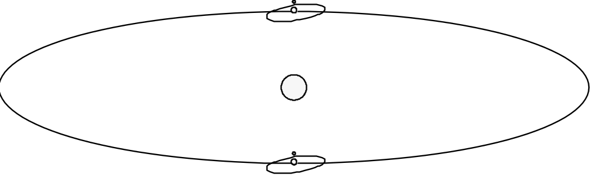
7. Why is the moon still visible, but copper-colored, during a full lunar eclipse?

8. Why do lunar eclipses last so much longer than solar eclipses?

Chapter 16 – The Atmosphere: Composition, Structure and Temperature

Earth-Sun Relationships (p. 455–460)

A. Earth's Motions
1. Rotation
a. What is meant by rotation of the Earth?

b. How long does it take the Earth to complete one rotation?

c. At any moment, what % of Earth is experiencing daylight?

d. What is the “circle of illumination?”

2. Revolution
a. What is meant by revolution of the Earth?

b. How long does it take the Earth to complete one revolution?

B. Seasons
1. Why is it colder in the winter than it is in the summer? Fully explain BOTH reasons.

a.

b.

2. How does the seasonal variation in the altitude of the noon sun affect the amount of energy received at the earth's surface? (in addition to reading the text, be sure to study Figure 16.10 on p. 456 and Figures 16.11 and 16.12 on p. 457)

a.

b.

3. Does every place on Earth experience a vertical noon sun on the same day? Explain.

C. Earth’s Orientation
1. Tilt (Inclination) of Earth's axis (be sure to study Figure 16.13 on p. 458):

a. Draw a diagram that illustrates how Earth's axis is tilted relative to the plane of Earth's orbit around the sun.

b. Over the course of a year, does Earth's axis always point in the same direction or does it point in different directions? Explain.

c. What are the implications of your answer to question b for the altitude of the noon sun at different times of the year. Answer this question in your own words and draw a diagram to illustrate your answer.

2. Seasonal Changes in the Location of the Vertical Rays of the Sun (In addition to reading the text, study Figure 16.13 and 16.14 on p. 458.)
a. The Summer Solstice and the Tropic of Cancer (23.5° N. Latitude)
Draw a diagram showing the tilt of Earth's axis relative to the sun on June 21 or 22 (The Summer Solstice). Show which part of Earth experiences a vertical noon-day sun and why.

b. The Winter Solstice and the Tropic of Capricorn (23.5° S Latitude)
Draw a diagram showing the tilt of Earth's axis relative to the sun on December 21 or 22 (The Winter Solstice). Show which part of Earth experiences a vertical noon-day sun and why.

c. The Autumnal and Vernal Equinoxes
Draw a diagram showing the tilt of Earth's axis relative to the sun on September 22 or 23 (The Autumnal Equinox) and March 21 or 22 (The Vernal Equinox). Show which part of Earth experiences a vertical noon-day sun and why.

3. Seasonal Changes in the Length of Daylight Versus Darkness (In addition to reading the text, study Table 16.1 on p. 459 and Figure 16.14 on p. 458.)
a. The Summer Solstice and the Northern Hemisphere: Explain why there are more hours of daylight than darkness during the summer in the Northern Hemisphere. Draw a diagram to illustrate your answer.

b. The Winter Solstice and the Northern Hemisphere: Explain why there are more hours of darkness than daylight during the winter in the Northern Hemisphere. Draw a diagram to illustrate your answer.

c. The Equinoxes: Explain why every place on earth experiences 12 hours of daylight and 12 hours of darkness on the Vernal and Autumnal Equinoxes. Draw a diagram to illustrate your answer.

Chapter 21 – Origins of Modern Astronomy

Positions in the Sky (p. 611-615)
A. The Celestial Sphere
1. What is the origin of the concept of the “Celestial Sphere?”
(In addition to reading the text, also study Figure 21.20 on p. 614.)

2. There really is no celestial sphere. So why do we still use the concept?

Constellations (p. 611–614)
A. What is the origin of the constellations that we use?

B. Are the stars in any particular constellation ACTUALLY close together or do they just look that way? Explain, using a diagram to illustrate your answer.

B. The Equatorial System
1. Celestial Poles:
a. Figure 21.21 (p. 614) shows a time exposure of the sky, centered around the North Star. The curved lines are the trails made by stars as they appear to orbit the North Star. Why do all of the other stars seem to orbit the North Star? Draw a diagram to illustrate your answer.

- How are the North celestial pole and the Earth's North Pole similar? How are they different?

2. Celestial Equator (For an illustration, see Figure 21.20 on p. 614.): How are the Celestial equator and the Earth's equator similar? How are they different?

The Motions of the Earth (p. 615–617)
A. Rotation
1. How long does it take the earth to complete one full 360° rotation?
2. Why are our standard “days” longer than this? (In addition to reading the text, carefully study Figure 21.23 on p. 615.)

B. Revolution
1. Apparent path of the sun
a. Over the course of a year, why does the sun appear to move relative to the stars? In addition to reading the text, carefully study Figure 21.C on p. 612.

b. Why is this apparent motion about 1° per day? (Hint: A circle has 360 degrees.)

2. Ecliptic (Study Figures 21.24 on p. 616)
a. What is the ecliptic?

b. Why do the moon, sun and planets always lie on or very close to the ecliptic? (In addition to reading the text, carefully study Figure 21.C on p. 612.)

c. The ecliptic does not line up with the celestial equator. Why not?

d. Complete the diagram below, showing the ecliptic and the celestial equator in their correct relative orientations.
Hint: the book DOES NOT have a diagram that shows this exact configuration.

e. If the Earth's tilt was 40° instead of 23.5°, how would the relationship between the celestial equator and the ecliptic be different? To illustrate your answer, complete the diagram below.

C. Precession (p. 616)
1. What is precession? In addition to reading the text, carefully study Figure 21.25 on p. 617.

2. How long does it take for Earth's axis to trace a complete circle across the sky?

3. Will Earth's axis always point toward Polaris (the North Star)? Explain.

Box 20.2 Astrology–the Forerunner of Astronomy (p. 612)
A. How is Astrology different from Astronomy?

B. How is the “zodiac” (Figure 21.C on p. 612) related to the ecliptic?
.

C. When astrological charts were first established, more than 3000 years ago, the sun was “in” Aries on the vernal equinox (around March 21st). Nowadays, on the vernal equinox, the sun is “in” Pisces. Why has this shift occurred?
Hint: This shift was caused by one of the motions of the earth you have just read about.

D. Explain the meaning of the expression “This is the dawning of the Age of Aquarius.”
Hint: This is also the “setting” of the “Age of Pisces.”

Calendars and Astronomy
A. The Days of the Week: The reason we have 7-day weeks is because our ancestors noticed seven heavenly bodies “wandering” among the stars on the celestial sphere. These seven heavenly bodies were the sun, the moon and the planets Mercury, Venus, Mars, Jupiter and Saturn. The outermost planets (Neptune, Uranus and Pluto) also “wander” but the ancients didn't know about them because you need a telescope to see them (which is a very good thing--can you imagine having 8-day workweeks?). Note that, as seen from Earth, the stars do not appear to move relative to each other. Keep in mind, however, that they really are moving but they are so incredibly far away that we cannot detect that movement.

Name the heavenly body that each day of the week is named after (some days are easier to figure out in Spanish so I included the Spanish names too):
1. Sunday (Domingo in Spanish)
2. Monday (Lunes in Spanish)
3. Tuesday (Martes in Spanish)
4. Wednesday (Miérocoles in Spanish)
5. Thursday (Jueves in Spanish)
6. Friday (Viernes in Spanish)
7. Saturday (Sábado in Spanish)

Objectives
When you have completed this lab you should be able to…
1. Demonstrate and illustrate how the relative positions of the sun, earth and moon cause the phases of the moon as seen from earth.
2. Given a drawing or photograph of the moon in any phase, be able to correctly name that phase and draw a diagram showing the relative positions of Earth, the moon and the sun for that phase.
3. Given a diagram showing any possible set of relative positions of Earth, the moon and the sun, determine the name of the moon phase and draw what the moon would look like in that phase.
4. State which way the moon revolves around Earth and describe a method for figuring this out.
5. Demonstrate why we always see the same side of the moon (the face side of the “man in the moon”)
6. Demonstrate what causes lunar and solar eclipses.
7. Explain why eclipses don't happen every month

Lab Activity #1: What do You Think Causes the Phases of the Moon?
Activity: Draw a diagram, explaining any theories you have about why the moon goes through phases. Briefly explain your theory to your group members. At this point, don't evaluate your idea or anyone else's. Just let each person state his/her ideas.

Lab Activity #2: Modeling the Phases of the Moon
Materials: White polystyrene ball, 3 inches in diameter (to represent the moon)
Pencil or other “stick”
Glowing light bulb (to represent the sun)

Activity:
1. Place the ball on the pencil.
2. Your instructor will turn on one light bulb and turn off all other lights in the room. The light bulb represents the sun, the white ball represents the moon and your head represents the earth. Imagine your nose as a giant mountain on the Earth's northern hemisphere with a tiny person standing on it (partially sideways), looking at the moon--see diagram below.
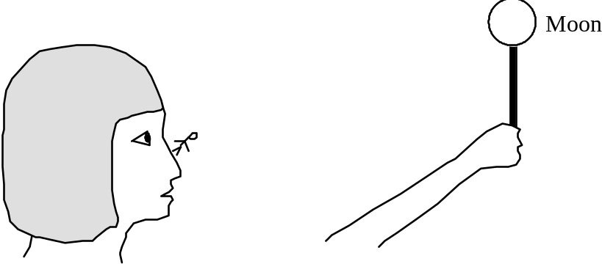
3. Hold the pencil with the white ball on it at arm's length in front of you and a little above your head. Slowly rotate your body, keeping the “moon” in front of you and watching as various parts of the white ball become lit and/or shaded.

Questions:
1. Draw diagrams showing the positions of the light bulb, your head, and the white ball (all as seen from the ceiling) for each of the following phases:
a. Full Moon (the part of the ball that you can see is fully lit ):

b. Quarter Moon (the part of the ball that you can see is half lit):

c. New Moon (the part of the ball that you can see is fully in shadow):

2. At any given time, what percentage of the model moon is actually lit? . Why?
If you are unsure of the answer to this question, watch the white ball as a partner repeats the activity described above.

Lab Activity #3: Determining which way the moon revolves around Earth
Materials: 3" diameter white polystyrene ball (to represent the moon) on a pencil
Glowing light bulb (to represent the sun)
Introduction
We have all known, from a very young age, that the moon revolves around Earth and that it takes about a month to do so--hence the word mo(o)nth. But have you ever stopped to wonder which way the moon revolves around Earth? Does it revolve from east to west (clockwise when looking down on Earth's north pole) or from west to east (counterclockwise when looking down on Earth's north pole)? In this activity, we will figure out the answer to this question.
We will do this by using the time-honored scientific technique of “predicting” what we would observe IF a particular possible answer were correct. If we don't observe what we predicted, then we know that that particular possible answer is wrong. If we do, indeed, observe what we predicted, then that possible answer has a high probability of being correct. In this case, we have only two possible reasonable answers to our question, so the most reasonable right answer should be easy to determine by elimination.
Activity: For each possible answer to the question of which way the moon revolves around Earth (west-to-east or east-to-west), use the “moon on a stick” to “predict” which side of the moon (left or right) would be lit during the waxing phases and which side of the moon would be lit during the waning⁴ phases--as seen from the northern hemisphere.
Questions:
1. Complete this table | Side of the moon that would be lit during the waxing phases (right or left) | Side of the moon that would be lit during the waning phases (right or left)
If the Moon revolves from east to west (clockwise when looking down on Earth's north pole)
If the moon revolves from west to east (counterclockwise when looking down on Earth's north pole)

2. According to your observations of the moon over the past month (as part of the moon project),
a. Which side of the moon is actually lit during the waxing phase?
b. Which side of the moon is actually lit during the waning phase?
3. Conclusion: Which way does the moon actually revolve around Earth?

Lab Activity #4: Synthesizing Your Understanding of the Phases of the Moon
Materials: 3" diameter white polystyrene ball (to represent the moon) on a pencil
Glowing light bulb (to represent the sun)
Partially completed “pop-up” moon diagram on card stock

Activity: Follow the instructions below to complete diagram on the card stock, turning it into a pop-up diagram. The circle in the center of the diagram represents the Earth and the eight small circles around it represent the moon at eight different positions on its orbit around Earth. Note that this pop-up diagram is not to scale. For reference, here are the earth and moon in the correct proportions with regard to both size and distance:
Instructions
1. On the diagram, write “To the sun” with an arrow pointed in the appropriate direction.
2. The partially-cut-out rectangles all around the diagram will show what the moon would look like to a person living near the equator who looks up through a skylight and sees the moon on eight different days (or nights) in the moon's cycle. Fold each rectangle up to represent a skylight above the person's head.
3. For each of the eight positions of the moon, darken the appropriate part of each circle in each “skylight” to show what the moon looks like to the person on Earth, directly below the moon. Draw each sketch in the box “above” the appropriate moon position (“Right side up” will be different for each moon-and-box pair; the Earth will be at the bottom for each).
4. “Above” each moon sketch, write the correct name for the phase of the moon (new, waxing crescent, waning crescent, 1st quarter, 3rd quarter, waxing gibbous, waning gibbous, full).
5. “Below” each sketch of the moon, write the approximate day in the moon's 29-day cycle.

Lab Activity #5: Why Do We Always See the Same Side of the Moon?
Introduction: Have you ever noticed that the pattern of light and dark spots (forming a “man” or “rabbit” in the moon) is the same all the time, no matter what phase the moon is in? This is because, from Earth, we can only see one side of the moon (See Figure 22.3 on p. 629 of the textbook or this cool(!) web site movie: http://antwrp.gsfc.nasa.gov/ apod/ap991108.html or this very sharp still image: http://antwrp.gsfc.nasa.gov/apod/ image/0001/fm1222_gendler_big.jpg). The other side of the moon is always turned away from us--to see a photograph of the far side of the moon, go to the following web site: http://antwrp.gsfc.nasa.gov/apod/ap981008.html.
Materials: Two people
Photographs of the “near” and “far” sides of the moon
Activity: Examine the photographs of the “near” and “far” sides of the moon; note how unfamiliar the “far” side of the moon looks. Choose one person to model the moon and one to model Earth. Have both people stand up and then have the “moon” revolve around “Earth” so that “Earth ” can only see the “moon's” face, never the back of the “moon's” head.
Questions:
1. For each 360° revolution of the “moon” around “Earth,” how many times did the “moon” rotate (spin about its axis) 360°? Explain.

2. What would happen if the “moon” did not rotate (e.g. always faced the front of the classroom) as it revolved around “Earth?”

3. Does the real moon rotate? If so, how long does it take to complete one 360° rotation? Explain the reasoning behind your answer.

Lab Activity #6: What Causes Solar and Lunar Eclipses?
Materials: White polystyrene ball, 3 inches in diameter (to represent the moon)
Pencil or other “stick”
Glowing light bulb (to represent the sun)

Activity: As in activity #2, hold the ball out in front of you, but hold it level with your eye. Face the light bulb and hold the ball so that it blocks the light; it may help to close one eye.

Question: 1. What kind of eclipse are you modeling?

More Activity: Now face away from the light bulb and hold the ball so that the shadow of your head covers the ball.

Question: 2. What kind of eclipse are you modeling?

More Questions:
3. What phase is the moon in during a lunar eclipse?

4. What phase is the moon in during a solar eclipse?

5. Describe what causes a lunar eclipse. Draw a diagram to illustrate your answer.

6. Describe what causes a solar eclipse. Draw a diagram to illustrate your answer.

Lab Activity #7: Why Don't We Have Solar and Lunar Eclipses Every Month?
Introduction: As you know, in any given place, a total lunar eclipse occurs less than once a year. And a total solar eclipse is a once-in-a-lifetime phenomenon (I've never seen one). In this activity, we will figure out why. We will do this by making a true-to-scale model of the moon and Earth (the sun will NOT be to scale in this model).
Materials: 3" diameter white polystyrene ball (to represent the EARTH this time) on a pencil
7/8" diameter white polystyrene ball (to represent the MOON)
paperclip
Overhead Projector (to represent the sun)

Activity: Lunar Eclipse
1. “Unbend” one fold of the paperclip and insert the end into the 7/8" diameter polystyrene ball, providing a “stick” for holding up the ball.
2. As a group, go to the room adjacent to the lab room where the overhead projector is set up, bringing one model moon and one model Earth along. With one person holding the moon and one person holding the Earth, place the moon and Earth exactly 8 feet apart in a line with the projector so as to model a lunar eclipse true to scale.
3. Move the moon or Earth slightly up or down, noticing how precisely the moon and Earth must line up in order for a lunar eclipse to occur.

Questions:
1. Why don't we have a lunar eclipse every month? Draw a diagram to illustrate your answer.
Hint: the plane of the moon's orbit around the earth is 5° off of the plane of the earth's orbit around the sun.

2. Will a lunar eclipse be visible from every place on Earth that is facing the moon? Explain the reasoning behind your answer and draw a diagram to illustrate your answer.

3. A lunar eclipse only lasts a few hours. Why?

Activity--Solar Eclipse: Now model a solar eclipse.

Questions:
4. Why don't we have a solar eclipse every month? Draw a diagram to illustrate your answer.

5. Will a solar eclipse be visible from every place on Earth that is facing the moon? Explain the reasoning behind your answer and draw a diagram to illustrate your answer.

6. A solar eclipse only lasts a few minutes. Why?

End-of-Lab Thought Questions

1. Will the moon have the same phase at all locations on Earth (North America, Europe, Venezuela, Argentina)? Explain the reasoning behind your answer.

2. What makes the moon rise and set? Does it do so at the same time every day? Why or why not?

3. How long does a “day” last on the moon (i.e. how many hours/days/weeks of daylight does any given spot on the moon experience between sunrise and sunset)? How do you know?

Objectives
When you have completed this lab you should be able to
1. visualize the proportions of the solar system--the sizes of objects and distances between them.
2. clearly and fully explain why it is warmer at the equator than it is at the poles.

Lab Activity #1: Scale Model of the Solar System
In this scale model, 1 mm in the model = 2000 km in real life.

Object | Diameter | Diameter for Scale Model | Average Distance from Sun | Distance for  Scale Model
Sun | 1,400,000 km | 700 mm | –– | ––
Mercury | 4,900 km | 2.45 mm | 58,000,000 km | 29 m
Venus | 12,100 km | 6.0 mm | 108,000,000 km | 54 m
Earth | 12,750 km | 6.4 mm | 150,000,000 km | 75 m
Earth's moon | 3,500 km | 1.8 mm | 385,000 km from Earth | 0.19 m from Earth
Mars | 6,800 km | 3.4 mm | 228,000,000 km | 114 m
Jupiter | 142,600 km | 71.3 mm | 778,000,000 km | 389 m (≈ 1/4 mile)
Saturn | 120,500 km | 60.3 mm | 1,427,000,000 km | 714 m (≈ 1/2 mile)
Uranus | 51,100 km | 25.5 mm | 2,869,000,000 km | 1435 m (≈ 0.9 mile)
Neptune | 49,500 km | 24.8 mm | 4,497,000,000 km | 2249 m (≈1.4 miles)
Proxima Cen-tauri (nearest star, a companion of Alpha Centauri) | 200,000 km | 100 mm | 4.24 light years (40,300,000,000,000 km | 20,140 km  (12,590 miles)
Materials: 12 spherical objects of various sizes and colors
Ruler (with cm on it)
Tape measure (with meters on it)
Activity:
a. Choose an appropriate spherical object to represent each object in the solar system (there isn't one given for Alpha Centauri).
List the model objects that you used for each item in the solar system:

Real Object | Model Object
Sun | Large 28 inch yellow ball
Mercury
Venus
Earth
Earth's moon
Mars
Jupiter
Saturn
Uranus
Neptune
Pluto
b. Go outside to the Children's Playground and make a scale model of the solar system as far out as Mars. Put the sun on the north (creek) side of the park. As a class, walk from the “sun” to the location of each planet, leaving a lab stand on the ground to mark the location of each planet so that you can see it from the next planet out. Note the apparent size of the “sun” from Earth--it should look about as large as the real sun looks in the sky.
For those who might wish to make a model of the entire solar system at this scale, here are the locations of the planets beyond Mars on this scale model.
Planet | Scale Model Location
Jupiter | Corner of Broadway and 4th St.
Saturn | Corner of Broadway and 7th St.
Uranus | Corner of Park and 13th St.
Neptune | Corner of Park and 21st St.
Pluto | Where Park turns east and heads toward the freeway
WARNING! This model can lead to misconceptions if you're not careful. In reality, the planets are never in a straight line like this; they all orbit the sun at different speeds and so are scattered in all directions around the sun.
Questions (to be answered after returning to the lab room) As you answer these questions, think about the proportions of the solar system and the implications of those proportions.

1. Which diagram below more accurately portrays the pattern of sun rays hitting Earth? Why?
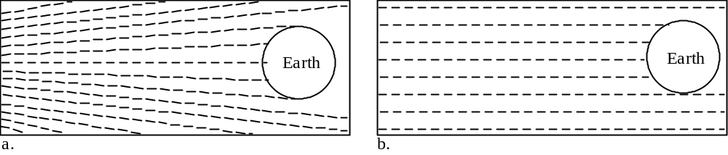

2. On Earth, is the equator closer to the sun than are the poles?
If so, is this difference significant when compared to the total distance between Earth and the sun? Explain.

Lab Activity #2:
Why Is It Warmer at the Equator Than At The Poles?
Materials: Overhead transparency with a grid printed on it
overhead projector
sturdy flat sheet of white poster board
large globe
flashlight
grid paper (at end of this lab)
Activity: Place the overhead transparency on the overhead projector; turn on the projector and project the image of the grid onto the sheet of white poster board. The overhead projector represents the sun. The flat sheet of poster board represents a theoretical flat earth with the flat side directly facing the sun. Note the sizes and the brightness of the squares projected onto the various parts of the piece of poster board.
Questions
1. Are all of the squares projected onto the piece of poster board the same size and brightness or are there variations? Draw a diagram to illustrate your answer.

2. If Earth were flat like the poster board is, would the intensity of sunlight be the same at all latitudes on Earth? Explain.

3. Imagine a tiny person standing on various places on your model of a flat earth--the piece of poster board (your person would be standing sideways). If the Earth were flat like the poster board is, would the noonday sun be directly overhead at all latitudes on Earth, or would there be some variation? Explain. Draw a diagram to illustrate your answer.

More Activity: Place the overhead transparency on the overhead projector; turn on the projector and project the image of the grid onto a large globe. The overhead projector represents the sun. The globe represents the Earth (now realistically represented as a sphere). Note the sizes and the brightness of the squares projected onto the various parts of the globe.
4. Are all of the squares projected onto the globe the same size and brightness or are there variations? Draw a diagram to illustrate your answer.

5. Is the intensity of sunlight the same at all latitudes on Earth? Explain. Draw diagrams to illustrate your answer.

6. Imagine tiny people standing at various latitudes on your globe. Would all of these people see a noonday sun directly overhead, or would there be some variation? Explain. Draw a diagram to illustrate your answer.

More Activity: In order to better understand why the intensity of the light hitting various parts of Earth varies, we will explore the relationship between the angle of incident light and the intensity of the light.
1. Shine the flashlight straight down on your grid paper, holding the flashlight 2–3 inches above the paper. On the paper, outline the middle (bright) spot.
2. From the same height, shine the flashlight at an angle to your grid paper. Again, outline the middle (bright) spot.

7. When light strikes a surface at a high angle of incidence (near 90°), the intensity of the light is
stronger / weaker (circle the correct answer)
than it is when the same light strikes a surface at a small angle of incidence (near 0°).

8. Clearly and fully explain why the angle at which light strikes a surface affects the intensity of the light energy felt by that surface.

9. There's one more piece to the puzzle of why the equator is warmer than the poles. This piece of the puzzle involves the atmosphere. The atmosphere absorbs, reflects and scatters sunlight; the more atmosphere a ray of sunlight must go through to get to the ground, the less energy will make it all the way to the ground. Imagine an atmosphere of uniform thickness covering your model Earth. Would sunlight have to go through the same thickness of atmosphere to reach the equator as it would to reach the poles? Explain. Draw a diagram to illustrate your answer.

10. Use all the concepts you have learned so far to fully explain why the equator is warmer than the poles.


Objectives
When you have completed this lab you should be able to show how the tilt of Earth’s axis and Earth’s revolution around the sun causes seasonal variations in…
• Temperature
• Day length
• Height of the noonday sun

Lab Activity #1:
Eliciting Your Understanding of the Causes of the Seasons
Introduction: We have just figured out why the equator is warmer than the poles. But, as you well know, our weather is not the same all year round. It is warmer in the summer than in the winter. The purpose of this activity is for you to realize exactly what you know (or at least what you think) about the causes of the seasons.
Materials: glowing light bulb (to represent the sun)
Polystyrene ball with a stick through it (the stick represents Earth's axis)

Activity: Within your group, take turns expressing your ideas about the causes of the seasons. Use the lamp and small globe as props for your explanations. Don't try to be “correct;” try to express what you REALLY believe. One piece of IMPORTANT information: Earth and all the other planets orbit the sun in a flat plane; Earth is never significantly “above” or “below” the level of the sun. Keep this in mind when you demonstrate your ideas; i.e. as you demonstrate Earth's orbit, keep the model Earth at the same height as the model sun (the light bulb).

Questions: Try to reach consensus within your group and construct a new group model that explains Earth's seasons. Describe and illustrate this model below.

Lab Activity #2: Testing, Refining and Applying Your Model
of the Causes of the Seasons
Introduction: Part of the scientific process is to constantly test models to see if they can account for all observations. If they do not, we modify them. During this activity, you will be testing your model and modifying it (or starting over) as necessary in order to account for all the observations listed below.
Materials: Glowing light bulb (to represent the sun)
Polystyrene ball with a stick through it (the stick represents Earth's axis)
Activity: For each observation below, use the materials above to explain the cause of each observation. If your model is not compatible with a particular observation, refine, add to or change your model as necessary.
A. The Shape of Earth's Orbital Path: The table on page C-27 of this lab manual notes the average distance of Earth from the sun (150,000,000 km). The actual distance varies during the year because Earth's orbit isn't perfectly circular. The table below provides Earth's average distance from the sun during selected months of the year.

Month | Average Earth-Sun Distance
January | 147,000,000 km
March | 149,000,000 km
June | 153,000,000 km
July | 153,000,000 km
September | 150,000,000 km
December | 148,000,000 km
1. When is Earth closest to the sun?
When is Earth farthest from the sun?
2. Can the distance between Earth and the sun account for the seasons?
Explain the reasoning behind your answer.

B. The North Star Stands Still: At any particular latitude of the northern hemisphere, the North Star is always in the same place in the sky (always straight north, always the same distance from the horizon); no matter what time of day you look or what day of the year it is.
Does your current working model “predict” this result? If so, use the polystyrene ball and the light to show how your model explains why the North Star “stands still.” If your group model does not predict this result, construct a new model that does and describe how this new model can explain why the North Star stands still.

C. Timing of the Seasons in the Northern and Southern Hemispheres: When it is summer in California (northern hemisphere), it is winter in Argentina (southern hemisphere) and visa versa.
Does your current working model “predict” this result? If so, use the polystyrene ball and the light to show how your model explains why summer and winter are reversed in the northern and southern hemispheres. If your group model does not predict this result, construct a new model that does and describe how this new model can explain why the seasons are reversed in the northern and southern hemispheres.

D. Lengths of Days and Nights
• At the equator, where it is almost always warm, days and nights each last exactly 12 hours all year round.
• Everywhere other than the equator, days are longer in summer than in winter. The longest day for us in the northern hemisphere is on the summer solstice (around June 21); the longest day for the southern hemisphere is on the winter solstice (around December 21). For example, in Chico the days are almost 15 hours long on June 21, but they are less than 9 ½ hours long on December 21. The closer you get to the poles, the more pronounced this difference is. For example, in Anchorage, Alaska, the days are 18 ½ hours long on June 21, but they are only 5 ½ hours long on December 21.
• At the North Pole, it is dark from the autumnal equinox (around September 21) through the vernal equinox (around March 21) and light from the vernal equinox to the autumnal equinox. When it is light at the North Pole, it is dark at the South Pole and visa versa.
• At all locations on Earth other than the poles, there are exactly 12 hours between sunrise and sunset on the dates of the equinoxes.
Activity: Draw a dot on your polystyrene ball to represent Chico. Place the polystyrene ball in the appropriate positions relative to the light to represent the solstices and equinoxes. Note that you can easily see the circle of illumination (the line between day and night) on the ball. At each position, spin the ball on its axis to model Earth's rotation. Notice how long Chico is in the light and how long it is in the dark at each position.
Questions:
1. Can your model for the cause of the seasons “predict” this change in the length of the day with the seasons? If so, explain how. If not, refine your model as needed so that it will “predict” the changes described above.

2. Can the change in the # of hours of daylight over the course of a year help (it doesn't have to be the only factor) explain the differences in temperature between summer and winter? If so, explain how. If not, explain why not.

E. Attributes of the Tropics of Cancer and Capricorn:
• At 23.5° North latitude (the Tropic of Cancer), the sun is directly overhead at noon on the summer solstice (around June 21).
• At 23.5° South latitude (the Tropic of Capricorn), the sun is directly overhead at noon on the winter solstice (around December 21).
Activity: Draw two circles on your polystyrene ball in the appropriate positions to represent the Tropic of Cancer and the Tropic of Capricorn. Place the polystyrene ball in the appropriate positions relative to the light to represent the summer and winter solstices.
Question: What is special about the Tropics of Cancer and Capricorn at the solstices that can account for the above observations? Use your model for the seasons to explain how.

F. Attributes of the Arctic and Antarctic Circles:
• At 66.5° North latitude (the Arctic Circle), the sun never sets on the summer solstice (around June 21); on all other days, the sun does go down at least for a little while. Everywhere north of the Arctic Circle, there are even more days when the sun never sets in the summer (the further north you go, the more days there are with 24 hours of light--“Midnight Sun”).
• At 66.5° North latitude (the Arctic Circle), the sun never rises on the winter solstice (around December 21); on all other days, the sun does make an appearance. Everywhere north of the Arctic Circle, there are even more winter days when the sun never rises (the further north you go, the more days there are with 24 hours of darkness).
• At 66.5° South latitude (the Antarctic Circle), the situation is similar but reversed (substitute June 21 for Dec. 21 and visa versa).
Activity: Draw two circles on your polystyrene ball in the appropriate positions to represent the Arctic and Antarctic circles. Place the polystyrene ball in the appropriate positions relative to the light to represent the summer and winter solstices. Rotate the ball on its axis to represent Earth's rotation.
Question: What is special about the Arctic and Antarctic Circles at the solstices that can explain the above observations? Use your model for the seasons to explain how.

Introduction
Up until this point, we have spent our time in the planetarium focusing on the apparent daily motion of the stars as seen from Chico. This motion is due to Earth's rotation and is the same day after day, year after year. We will now focus on two more complicated concepts:
1) Apparent daily motion of the stars as seen from the equator and from the North Pole.
2) The apparent long-term motion of the sun. The sun displays the same daily apparent motions as the stars do and, in the course of one day, it seems to maintain a fixed position with respect to the stars. However, if we carefully observe the sky for several days, weeks or months (similar to what you did as you conducted your moon study), we can detect a motion of the sun relative to the stars.
In the planetarium, we can see what the night sky looks like at distant locations on earth without actually having to travel there. We can also make observations very efficiently by speeding up time. Best of all, we can take away the apparent motions that are caused by Earth's rotation. Imagine taking a photograph of the sky at exactly the same time every night for many nights in a row; if you put those photographs together and made a movie, it would be similar to what we can show in the planetarium. The planetarium also gives us the power to make the sun so dim that we can still see the stars during the daytime. In summary, using the power of the planetarium, we will not see any apparent daily motions due to the Earth's spin; we will only see the apparent annual motion of the sun due to the Earth's revolution around it.

Objectives
When you have completed this lab you should be able to
1. Use the altitude (angle above the horizon) of Polaris to determine your latitude.
2. Describe the apparent nightly motion of the stars as seen from the North Pole and from the Equator and explain why the stars seem to move the way they do at these locations.
3. Describe the apparent annual motion--i.e. apparent motion due to Earth's revolution--of the sun across the constellations and explain why it seems to move the way it does.
4. Describe the difference between the Ecliptic and the Celestial Equator.
5. Discuss the astronomical basis for Astrology (movement of the sun, moon and planets through the signs of the Zodiac) and why scientists have no faith in Astrology.
Lab Activity #1: Modeling the Apparent Motion of the Sun Through the Constellations of the Zodiac
More Activity: (Do this activity as a whole class) One person represents the earth, another represents the sun and everyone else represents stars. Form a large circle with the “sun” in the center and the “earth” next to the sun. Space the various “stars” unevenly around the circle. Everyone stays in place except the “earth.” The “earth” will spin and orbit around the “sun” (be sure to spin and orbit in the proper directions).
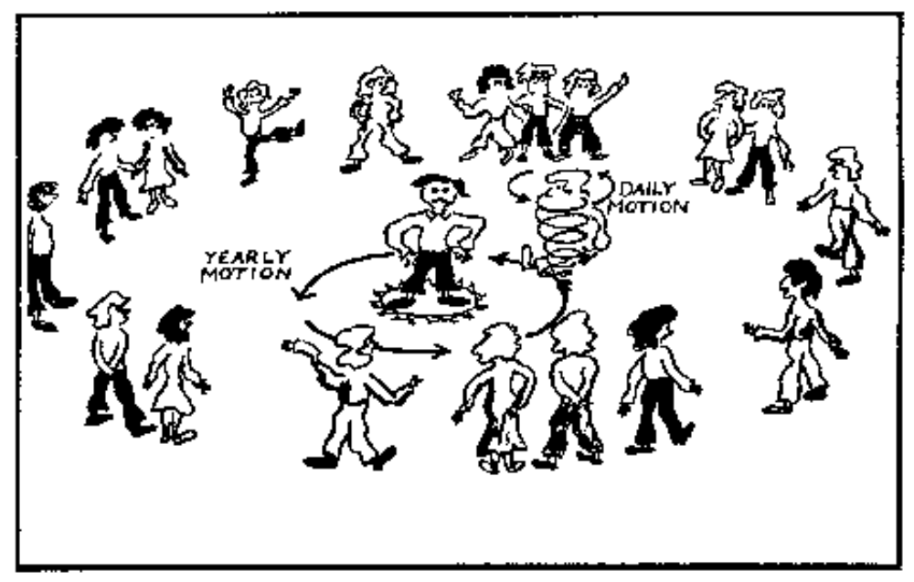
Illustration of the Activity
(Source: p. 30 of the chapter on Planets in The Universe at Your Fingertips: an Astronomy Activity and Resource Notebook: Astronomical Society of the Pacific, 1995).

Lab Activity #2: Watching the Sun Move Through the
Constellations of the Zodiac
Activity: Go into the planetarium. Your instructor will show what you would see if you continually kept your gaze on the same stars for a year and watched the apparent motion of the sun as Earth circled around it. The path apparently followed by the sun in this demonstration is called the ecliptic.
Question: As the sun appears to move with respect to the stars, it passes “through” the twelve constellations of the Zodiac. What is causing this apparent motion of the sun across these constellations? Draw a diagram to illustrate your answer.

More Activity: The planetarium (and your “SC001 Constellation Chart”—handed out in class) shows the ecliptic as a smoothly curving line sweeping across the 12 constellations that correspond to the 12 signs of the Zodiac. Notice the dates inscribed along the ecliptic; each date marks the position of the sun (as seen from Earth) with respect to the background stars on that date.
Locate your birthday on the ecliptic. Then note the constellation that that location is “in” (or nearest to). Your astrological sun “sign” is supposed to be the constellation that the sun was “in” on your birthday. Locate the constellation that corresponds to the sun “sign” you have always considered yourself to be.
Questions
1. Is the sun actually “in” your supposed sun sign constellation on your birthday? If not, which “sign” is it “in?”

2. For those who have done the reading for homework #9, explain why, for most people, the sun is not in the “proper” constellation on their birthday.

Lab Activity #3:
Why Do We See Different Constellations at Different Times of the Year?
Activity: On the ceiling of the planetarium, watch the motion of the stars and the sun as seen from Chico for one 24-hour period (today's date).

Questions
1. If there were no sun and we could see stars all day and all night, would we be able to see the same constellations every day of the year? Explain the reasoning behind your answer.

2. If you were to stay up all night tonight and watch the stars, you would not see the constellations Libra or Virgo. Similarly, if you would stay up all night in the middle of June, you would not see some of the constellations that you learned earlier this semester--i.e. Orion, Taurus, the Pleiades, Canis Major and Gemini. Why are some constellations visible only part of the year?

3. Why can we see a greater variety of constellations in the winter than we can in the summer?

4. Right now (mid-Fall), Orion does not fully rise until 10 p.m. and it is still visible just before dawn. By contrast, in late April, Orion is visible as soon as the sun sets but it only stays up until around 9 p.m. In June, you will never see Orion at all. Explain these changes in the time of the night that certain constellations are visible.

Lab Activity #4: How the Night Sky Changes with Latitude
Introduction
Using the Planetarium, we can project the sky as it looks from any location on Earth at any time on any day of the year. What we will do is use the planetarium to study the positions and apparent daily motions of the stars as seen from two key locations: the North Pole and the Equator (you already did this for 40° North latitude--where Chico is).
Activity: On the ceiling of the planetarium, observe the altitude of the North Star and the daily motions of the stars with respect to the horizon, as seen from the equator, the North Pole, and Chico.
Questions
1. Complete the table below

 | Altitude of Polaris | Nightly Motion of the Stars With Respect to the Horizon
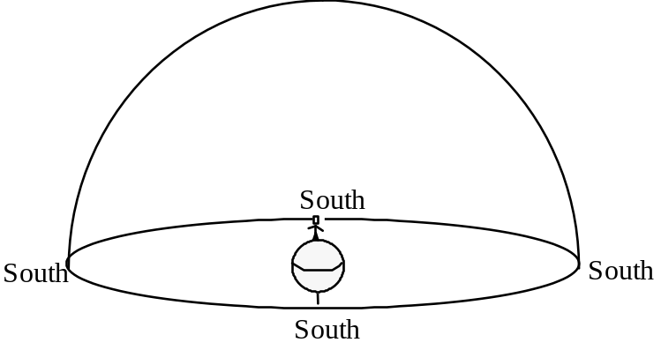
North Pole
Equator |  | 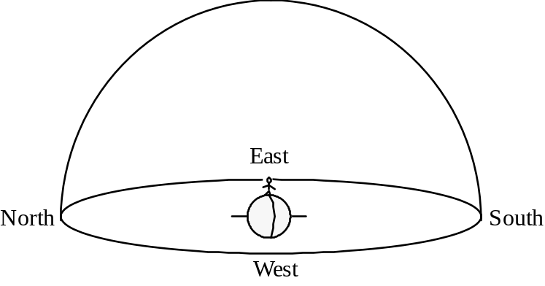
2. Describe a way to determine your latitude if you can measure the altitude of Polaris

3. Explain why Polaris is at different altitudes at different latitudes. To illustrate your answer, add to the diagrams below.

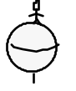
Person at the North Pole

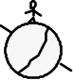
Person in Chico (at 40° N. Latitude)

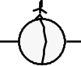
Person at the Equator
Lab Activity #5: The Apparent Path of the Noonday Sun
Activity: Your instructor will use the planetarium to show the path of the sun across the sky as you would see it (in Chico) if you looked up at the sky at the exact same time every day (our fixed time will be noon) and didn't look at any other time. As your instructor does this, notice that the background stars appear to move relative to the sun.

Questions
1. Draw the apparent path of the noonday sun (as seen from Chico) on the diagram below. Label the highest and lowest points with the appropriate dates.

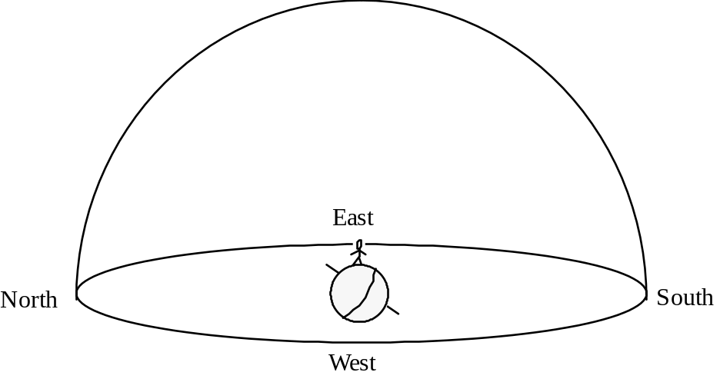

2. What is the altitude of the noonday sun on the summer solstice (±June 21)?
3. What is the altitude of the noonday sun on the winter solstice (±December 21)?
4. What is the altitude of the noonday sun on the equinoxes (±March 21 and Sept. 21)?

5. Using what you learned in the lab on seasons, explain why the noon-day sun is at different altitudes at different times of the year. To illustrate your answer, add to the diagrams below.

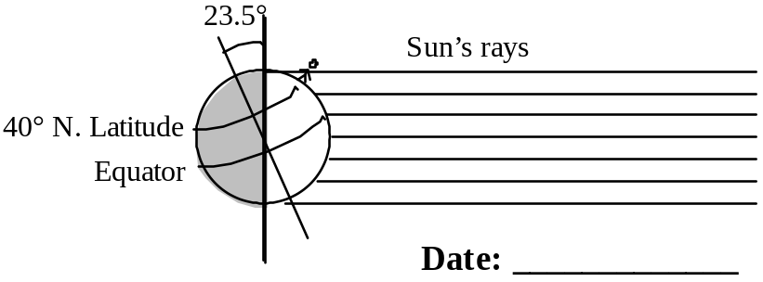

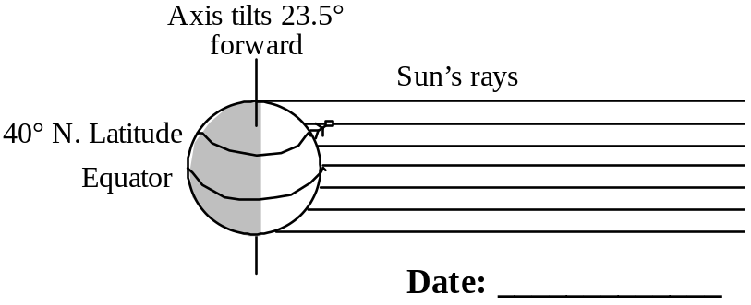

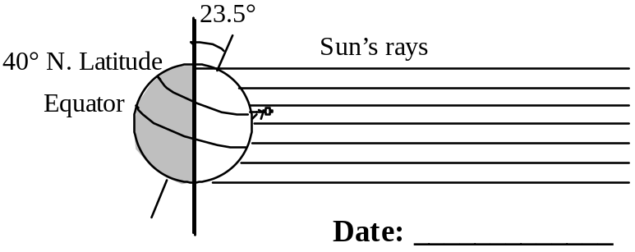
Objectives
When you have completed this lab you should be able to use the cardboard Solar Motion model and the Celestial Globe to figure out the apparent path of the sun across the sky for any date of the year at any location in the northern hemisphere. Specifically, you should be able to
1. Describe where (i.e. in the NE, E, SE, S, SW, W, NW) the sun rises and sets in various places on various dates and explain why the sun doesn't always rise exactly in the east or set exactly in the west.
2. Determine the approximate altitude of the noonday sun in various places on various dates and explain why that angle changes with latitude and season.

Important Information
• On the equinoxes ONLY, the sun rises exactly in the east and sets exactly in the west.
• In any 24-hour period, the sun always appears to travel parallel to the Celestial Equator
• On the equinoxes (March 21 and September 21),
the angle of the noonday sun = 90°– (your latitude).
• On the summer solstice (June 21), the angle of the noonday sun = 90°– (your latitude) + 23.5°.
• On the winter solstice (December 21), the angle of the noonday sun = 90°– (your latitude) – 23.5°

Lab Activity #1: The Apparent Daily Path of the Sun Across the Sky
Introduction: At any given location on Earth, the apparent daily path of the sun across the sky varies systematically with the seasons. This variation is due to the tilt of the Earth. Once you understand how this works, you can actually predict where the sun will rise and set on a particular date and how high the sun will be at noon. In this activity, you will use the model celestial sphere and a simple solar motion model to observe where the sun rises and sets and the height of the sun at noon at various times of the year in various places. This activity should deepen your understanding of the ramifications of Earth's tilt.
Materials: Celestial Globe
one Solar Motion model per person (You may keep them!)
Introduction to the Model Celestial Sphere: In this activity, you will use a celestial globe, which is a model of the celestial sphere just as a world globe is a model of the Earth. The stars are shown as white dots on a clear plastic sphere. The sun is a small yellow ball inside the clear plastic sphere and the earth is a larger ball in the center of the sphere.
As you are learning in Homework Assignment #9, the concept of a celestial sphere is useful for understanding the apparent motion of the stars in the sky, even though there really is no giant crystalline sphere--studded with stars--surrounding the Earth. As you do this activity, remember that not all aspects of the model celestial sphere are accurate (for example, the model earth is WAY too big and WAY too close to the sun; and the model sun goes around the model earth even though, as you well know, the earth actually revolves around the sun).
How to Use the Model Celestial Sphere
1. Twist the large white knob at the bottom of the model celestial sphere clockwise; this causes the Earth inside the Celestial Sphere to spin. Notice that the stars do not move, only the Earth does (the moon and the other planets would too--if they were incorporated into this model).
2. In order to model the sky as seen from Chico, tilt and rotate the model celestial sphere until Chico is at the “top” of the Earth. Hold the model celestial sphere above your head and look through the sphere at the stars depicted on the inside of the sphere. Try to identify some of the constellations.
Note: the configuration of the stars in each constellation looks correct--except the stars look way too big--only when you look at the inside surface of the sphere (you get a mirror image if you look at a constellation on the outside surface of the sphere). However, the printed labels look correct only when viewed on the outside surface of the sphere--very confusing, I know.
Be sure to give EVERY member of your group a chance to do this activity.
3. In order to model the motion of the stars as seen from Chico, hold the celestial sphere model in the same position as you did for Step #2 (described above). Then hold the large white knob (the one that controls the model Earth) fixed--keeping Chico “on top” of the world as you slowly spin the outside of the Model Celestial Sphere counterclockwise--as seen from below. This may take two people.
Be sure to give EVERY member of your group a chance to do this activity.

Activity:
1. For each of the various locations and dates listed below, determine the apparent path of the sun across the sky using the Celestial Globe and the Solar Motion model.
2. Complete the appropriate boxes in the tables.
Note on Locations of Sunrise and Sunset: Whenever the locations of sunrise and sunset are not exactly east and west, you do not have to determine an exact location; NW, NE, SW, or SE is good enough.
Note on Altitude of Sun: Whenever the altitude of the sun at noon is something other than exactly 0° or exactly 90°, you may simply state whether the angle is >45° or <45°.
Note on Number of Hours of Daylight: Whenever the # of hours of daylight is not exactly 0, 12 or 24 yours you may simply state “Less than 12 hours” or “More than 12 hours.”
3. On the hemisphere diagrams provided, draw the path of the sun at the solstices and equinoxes for each location (Chico, Tropic of Cancer, Equator, and North Pole). In addition, draw the North Celestial Pole and the Celestial Equator on each hemisphere diagram. Note: The locations of the pole and equator will be different for each diagram.
At Chico  (40° N. Latitude) | Equinoxes | Summer Solstice | Winter Solstice
Location of sunrise
Altitude (angle to horizon)
of sun at noon
Location of sunset
# of hours of daylight
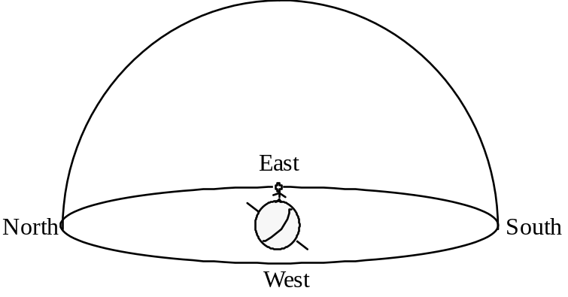
Draw the North Star, the Celestial Equator and all three paths of the sun.

At the Tropic of Cancer  (23.5° N. Latitude) | Equinoxes | Summer Solstice | Winter Solstice
Location of sunrise
Altitude (angle to horizon)
of sun at noon
Location of sunset
# of hours of daylight
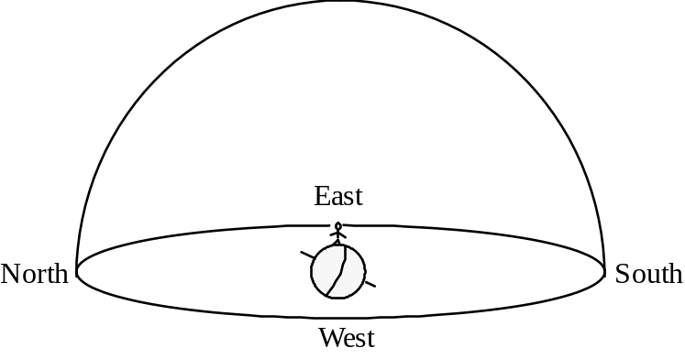
Draw the North Star, the Celestial
Equator, and all three paths of the sun.
At the Equator  (0° Latitude) | Equinoxes | Summer Solstice | Winter Solstice
Location of sunrise | East
Altitude (angle to horizon)  of sun at noon | 90°
Location of sunset | West
# of hours of daylight | 12
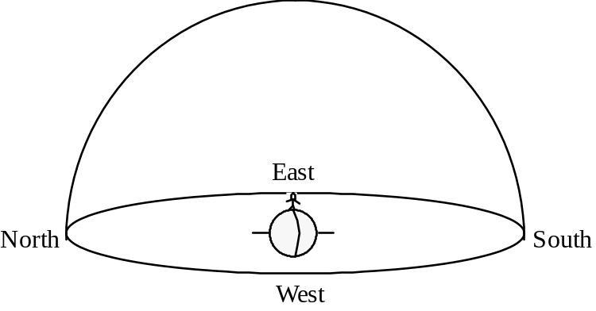
Draw the North Star, the
Celestial Equator and all
three paths of the sun.

At the North Pole  (90° N. Latitude) | Equinoxes | Summer Solstice | Winter Solstice
Location of sunrise
Altitude (angle to horizon)
of sun at noon
Location of sunset
# of hours of daylight
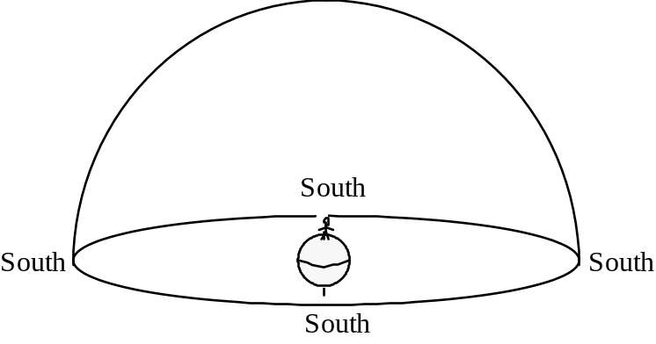
Draw the North Star, the Celestial
Equator, and all three paths of the sun.
A. Inventory of the Universe
1. Solar System
a. Definition:

b. # of Stars:
c. How is a star different from a planet?

d. Size and shape of our solar system:

e. What does our solar system look like from Earth?

f. What do other solar systems look like from Earth?

g. Our solar system is part of
h. How many solar systems are there?

i. How far apart are these solar systems?

2. Galaxy
a. Definition:

b. # of stars in our galaxy:
c. Size and shape of our galaxy:

d. Where are we relative to the rest of the galaxy?

e. What does our galaxy look like from Earth?

f. What do other galaxies look like from Earth?
g. Our galaxy is part of
h. How many galaxies are there?

3. Universe
a. Definition:
b. How many universes are there?
c. # of Stars:
d. How full of “stuff” is the universe?

e. Is this “stuff” evenly distributed or is it clumped?

f. How old is the universe?
B. Motion in the solar system, galaxy, and universe
1. Motion of the earth within the solar system:

a. Orbit:

b. Wobble of Axis:

2. Motion of the solar system within the galaxy:
a. Spin:

b. Random motion:

3. Motion of the galaxy within the universe:

4. If there is so much rapid motion, why have the constellations remained the same for thousands of years?

A. Review of Concepts Learned in the Lab “The Moon’s Phases and Eclipses”

1. Phases of the Moon
In the late 1960's and early 1970's, NASA sent a series of space missions to the moon. For the first time in Earth's history, people were able to view Earth as a whole on a single photograph--that is, they could see the part of Earth that faced them and was lit by the sun. You see, like the moon, Earth has phases.

On July 19, 1969, the Apollo 11 astronauts landed on the Sea of Tranquility (the Sea of Tranquility is not really a body of water; it is a huge basalt lava flow). Just before Neil Armstrong and Buzz Aldrin stepped out onto the moon for the first time, they took the picture of Earth that you see below (For those of you who saw the movie "Dish"--a great movie--you can now see why NASA had to use a satellite dish in Australia to broadcast the first moon walk).

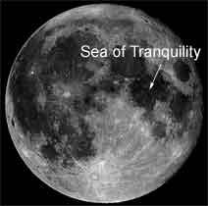 | 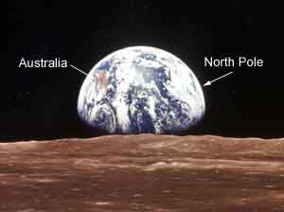

On July 19, 1969, what did the moon look like from Earth? Was the moon waxing or waning? Explain.

2. Solar Eclipses
a. What is the umbra?

b. What is the penumbra?

c. Why do only a few people actually get to see each solar eclipse?

d. Draw a series of three images of a solar eclipse.

e. Which way does the moon move across the sun? ____________________________
Why?

f. What is the solar corona?

3. Lunar Eclipses
a. Draw a series of three images of a lunar eclipse.

b. Which way does Earth’s shadow move across the moon?
Why?

4. Why don’t we see eclipses every month?

B. Formation of the Solar System
1. Making the Elements
a. Primordial matter of the universe:

b. How does nature make heavier elements?

c. How do you get those heavier elements out of the core of the star?

d. An earlier star:

2. Making the Solar System
a. Cloud of Dust

b. The planets and sun are born
Stage 1

Stage 2

Stage 3

Stage 4

Stage 5

c. How did our moon form?

F. Puzzle: Why are planets that are closer to the sun warmer than planets that are farther away from the sun? In other words, why is there a loss of intensity of electromagnetic radiation (heat, light, radio waves, microwaves, etc.) with distance?
1. Planets that are closer to the sun are warmer. Why?
Simple answer:
2. More complex answer:
a. It takes energy to move. Therefore a heat wave gradually loses energy as it travels.
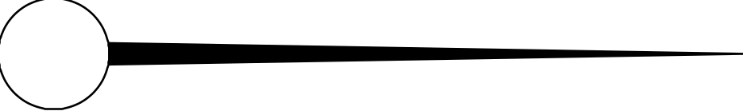
b. Heat waves spread out in all directions from a heat source. Therefore the concentration of energy decreases with distance.
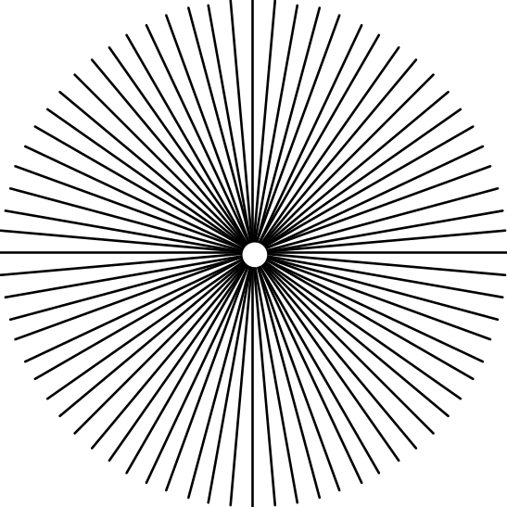
c. All of the above

Some Comments on the Real Exam
• This exam covers all material related to astronomy. Specifically, this exam covers:
All of Part C of your course packet
Planetarium Lab #1 (p. A–65 through A–68)
The moon project
• Be sure to bring the following items to the exam: Cardboard solar motion model
Star and Planet locator

Part 1: The Circumpolar Constellations
Materials
Model Celestial Sphere
Questions
1. Circle and name the five circumpolar constellations illustrated below. Identify and label the North Star.
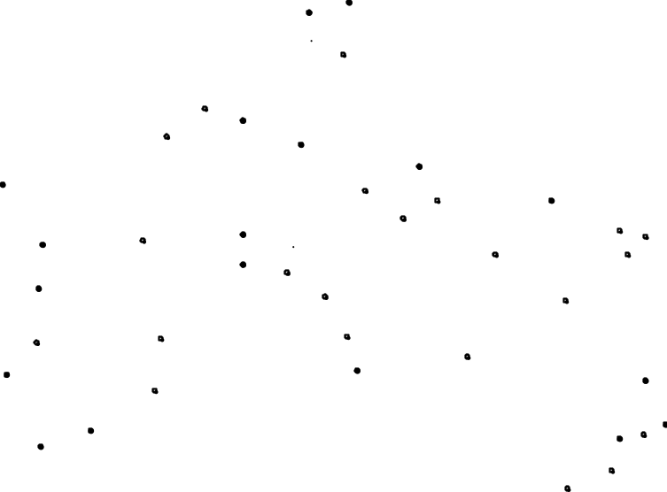
2. Describe and illustrate how you can use the North Star to determine your latitude.

3. Explain why the North Star “stands still.”

Part 2: Celestial Hemispheres
Useful Information
• On the equinoxes (March 21 and September 21), the angle of the noonday sun is 90°– (your latitude).
• On the summer solstice, the angle of the noonday sun is 90°– (your latitude) + 23.5°.
• On the winter solstice, the angle of the noonday sun is 90°– (your latitude) – 23.5°.
• In any 24-hour period, the sun always appears to travel parallel to the Celestial Equator.

Materials
Cardboard solar motion models
Clear plastic hemisphere
Pens designed for overhead projectors

Introduction: Imagine yourself in the middle of a very large flat treeless plain, looking up at the sky. The sky above you looks like a giant inverted bowl. You are inside the bowl, in the exact center. The sun, moon, planets and stars seem to move on the surface of this huge bowl.
We will now scale down this image. Imagine that you are the size of a pinhead. The lab table is the large flat plain and the small clear plastic hemisphere is the bowl that represents the sky.
Activity/Questions
On the clear plastic hemisphere (representing the sky above you), draw the path of the sun across the sky in Chico (latitude 40° N) for each of the following dates:
a. Vernal Equinox (around March 22)
b. Autumnal Equinox (around September 22).
c. Summer Solstice (around June 22)
d. Winter Solstice (around December 22)
• Be sure to label “North” on the sphere.
• Be sure to draw the paths at the correct compass directions and at the correct angles from the horizon (as close as you can get them).
• Describe how you figured out the paths, showing all the steps of any mathematical calculations you did.
Part 3: The Path of the Moon Across the Sky

Background Information
Most people know their astrological sun sign, but many people don't know that they also have a “moon sign,” (and a “Venus sign,” a “Mars sign,” etc.). Each of your “signs” is designated by the position of that celestial object in the sky, relative to the constellations of the Zodiac, at the time you were born. We will not ask you to comment on the significance (or insignificance) of your various signs with regard to your personality and future--those issues fall within the spiritual realm, not within the realm of science. But, we will ask you to explain why and over what period of time the moon travels through the various constellations of the Zodiac.
The plane of Earth's orbit around the sun is tilted at a 23.5° angle to the Earth's equator. By contrast, the plane of the moon's orbit around the Earth is tilted at a 5° angle to the plane of the Earth's orbit around the sun. As a result, the apparent path of the moon across the sky is a little different from the apparent path of the sun across the sky. But, for the purposes of this activity, these differences don't matter and we will use the model “Sun” on the Model Celestial Sphere to represent the moon.

Materials: Model Celestial Sphere

Activity: Turn the white knob on the outside of the Celestial Sphere to model the revolution of the moon around Earth. Note the path of the moon relative to the constellations of the Zodiac.

Questions:
1. How long does it take the moon to complete one cycle through the constellations of the Zodiac? Explain.

2. Explain why the moon travels through the constellations of the Zodiac.

3. The chronological order of the “Sun signs” is Capricorn–Aquarius–Pisces–Aries–Taurus–Gemini–Cancer–Leo–Virgo–Libra–Scorpio–Sagittarius. Do the moon signs go in the same order or do they go backwards? Explain.

4. How many days (approximately) does the moon take to travel through each sign of the zodiac?

Part 4: The Moon
Materials: White polystyrene ball on a pencil (to represent the moon)
Glowing light bulb (to represent the sun)
Activity: Use the ball on the stick and the light bulb to model the moon in its various phases.
1. Complete the table below, inserting the names of the moon phases, drawings of the moon and/or drawings of the positions of the moon, sun and Earth as appropriate. In your drawings of the moon, please leave the lit portion of the moon white and shade in the dark portion of the moon.

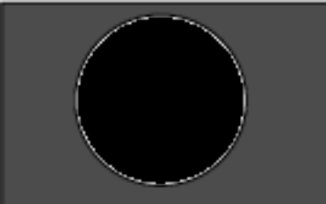  Moon Phase | Drawing of what the moon looks like from Earth  (northern hemisphere) | Drawing of Positions of moon, sun and Earth (looking down on Earth's North Pole)

Waxing Gibbous
1st Quarter

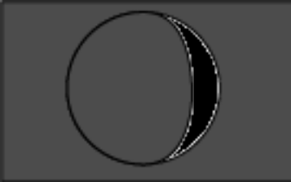
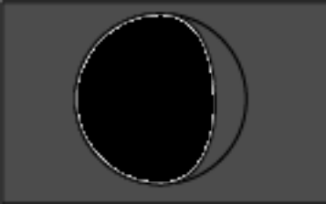
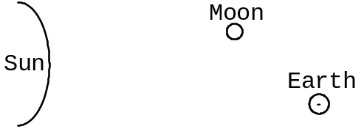

2. Questions about the photograph on the front cover of the course packet.
Photographers: Crew of the Apollo 8 NASA mission to the moon
Date of photograph: December 22, 1968
Title of photograph: View of rising Earth about five degrees above the Lunar horizon
Explanation: The rising Earth is about five degrees above the lunar horizon in this telephoto view taken from the Apollo 8 spacecraft near 110° east longitude. The horizon, about 570 kilometers (250 statute miles) from the spacecraft, is near the eastern limb of the Moon as viewed from the Earth. On the earth, the sunset terminator crosses Africa. The South Pole is in the white area near the left end of the terminator. North and South America are under the clouds. The lunar surface probably has less pronounced color than indicated by this print.

Questions
a. Why did the Earth look like a lop-sided football instead of a full circle?

b. What were the relative positions of the sun, Earth and moon on December 22, 1968?

c. On that same day (December 22, 1968), what did the moon look like from Earth (i.e. what was the phase of the moon?)

d. Why is the South Pole “up?”

e. From any one place on the moon, does Earth ever really “rise” or “set?”

Part 5: Multiple Choice
1. Why is it hotter at the equator than at the poles?
a. Because the equator is closer to the sun.
b. Because the sun's rays travel through more atmosphere at the equator.
c. Because the sun's energy is more spread out at the equator.
d. Because the sun's rays hit the earth's surface at a higher angle at the equator.
e. Because the sun is always directly overhead at the equator.
2. If the Earth's axis only had a 5° tilt, how would the seasons in Chico be different from how they are now?
a. The seasons would be shorter.
b. The transitions between seasons would be more abrupt.
c. The contrast in temperature between summer and winter wouldn't be as great.
d. Summer days would be longer than they are now and winter days would be shorter than they are now.
e. All of the above.
3. In Chico, the highest the sun ever gets at noon is ° above the horizon and the lowest the sun ever gets at noon is ° above the horizon.
a. 90°; 40°
b. 73.5°; 26.5°
c. 63.5°; 40°
d. 47°, 23.5°
e. 40°; 16.5°
4. You have been kidnapped and taken, blindfolded, to a remote site. You manage to peek outside one night and see the little dipper setting below the horizon. What is the approximate latitude of your location?
a. 0° (Equator)
b. 40° North
c. 40° South
d. 90° North (North Pole)
e. 90° South (South Pole)
5. We can see Orion in November but not in May because in November whereas in May .
a. Orion is directly above North America; Orion is directly above Europe.
b. Earth tilts toward Orion; Earth tilts away from Orion.
c. Polaris is high in the sky; Polaris is below the horizon.
d. The sun is in Orion; the sun is opposite Orion.
e. Earth is between the sun and Orion; the sun is between Earth and Orion.
6. “Each star seems to rise a little later each day.” True or false? Why?
a. True, because the stars revolve very slowly around Earth in the same direction that Earth rotates on its axis.
b. True, because the sun moves through the constellations of the Zodiac from west to east.
c. False. Actually, each star seems to rise a little earlier each day because the earth rotates a little farther than 360° every 24 hours.
d. False. Actually, each star rises at the same time every day because the position of each star is fixed on the Celestial Sphere.
7. The diagram below shows one possible configuration of the Earth and Moon. The white sides of the circles represent the sides that are lit up by the sun, which is too far away to show. The black sides are in shadow.
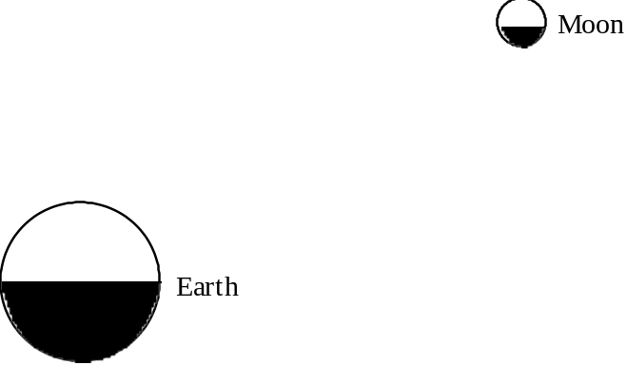
Note: The relative sizes of the Earth and Moon are correctly shown on this diagram but the distance between them is not to scale (to make the diagram to scale, the Earth and Moon would have to be shown 10x as far apart).
What would the moon look like from Earth?
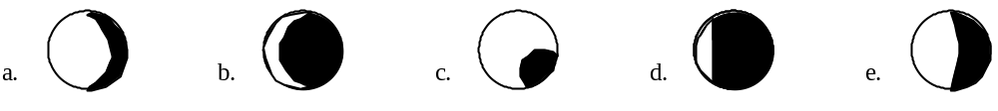

Part 1: The Circumpolar Constellations
Questions
1. Circle and name the five circumpolar constellations illustrated below. Identify and label the North Star.
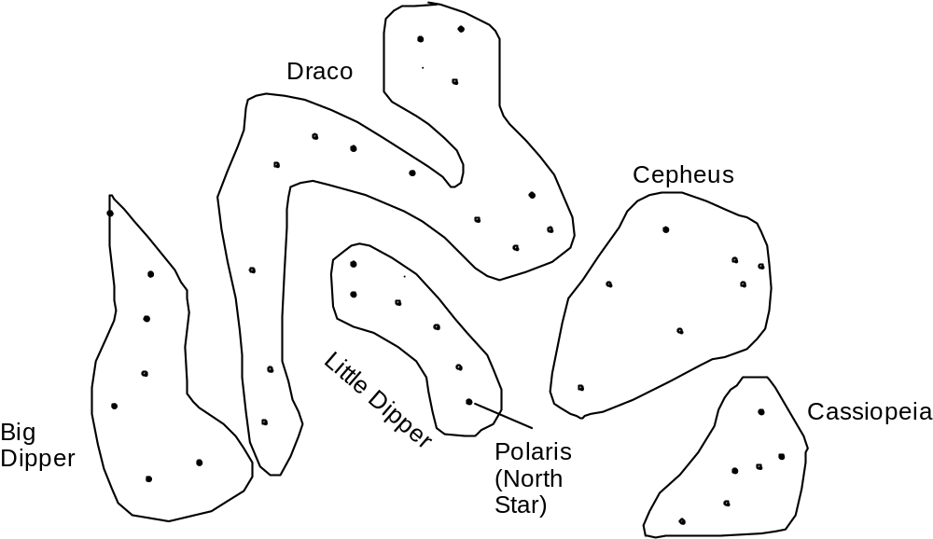

2. Describe and illustrate how you can use the North Star to determine your latitude.

At every place in the northern hemisphere, the altitude of the north star above the horizon is exactly equal to the latitude of that place.

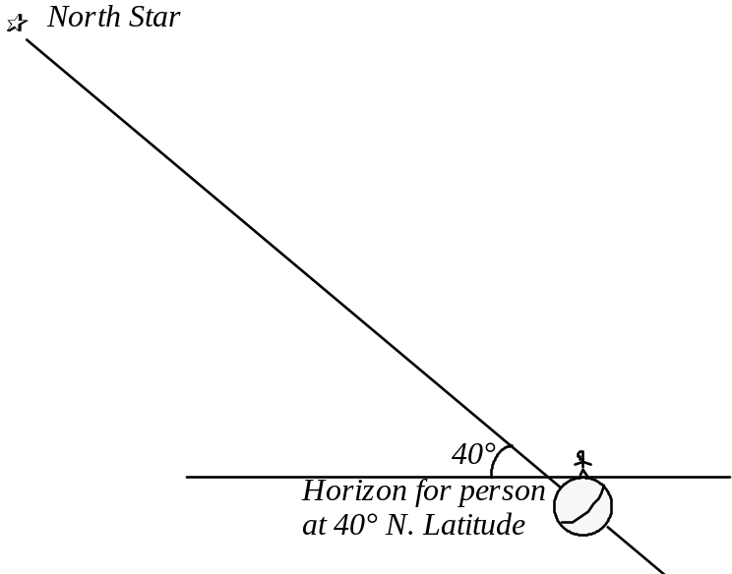
3. Explain why the North Star “stands still.”

As shown in the previous diagram, Earth's axis points directly at the North Star. Therefore, looking at the North Star is like looking at a spot on the ceiling directly above you as you spin around on a lab stool or other spinnable chair. That spot on the ceiling is aligned with your axis of rotation, so it does not appear to move. However, because you are spinning, it looks to you like everything but that spot is spinning in a circle around that spot.

Part 2: Celestial Hemispheres
Useful Information
• On the equinoxes (March 21 and September 21), the angle of the noonday sun is 90°– (your latitude).
• On the summer solstice, the angle of the noonday sun is 90°– (your latitude) + 23.5°.
• On the winter solstice, the angle of the noonday sun is 90°– (your latitude) – 23.5°.
• In any 24-hour period, the sun always appears to travel parallel to the Celestial Equator.

Activity/Questions
On the clear plastic hemisphere (representing the sky above you), draw the path of the sun across the sky in Chico (latitude 40° N) for each of the following dates:
a. Vernal Equinox (around March 22)
b. Autumnal Equinox (around September 22)
c. Summer Solstice (around June 22)
d. Winter Solstice (around December 22)
• Be sure to label “North” on the sphere.
• Be sure to draw the paths at the correct compass directions and at the correct angles from the horizon (as close as you can get them).
• Describe how you figured out the paths, showing all the steps of any mathematical calculations you did.
Answer: See the plastic hemisphere for the paths.
Angle of the noonday sun above the southern horizon (the sun is always exactly in the south at noon):
Vernal Equinox 50°
Summer Solstice 73.5°
Autumnal Equinox 50°
Winter Solstice 26.5°
The easiest way to draw these paths correctly is to use the cardboard solar motion models.
Precise calculations (using the information given in the question):
Equinoxes: 90°-(our latitude) = 90°-40° = 50°
Summer Solstice: 90°-40°+23.5° = 73.5°
Winter Solstice: 90°-40°-23.5° = 26.5°
Part 3: The Path of the Moon Across the Sky

Questions:
1. How long does it take the moon to complete one cycle through the constellations of the Zodiac? Explain.

It takes 27 days for the moon to complete one cycle through the constellations of the Zodiac. This is because it takes that long for the moon to make a full 360° circle around Earth. Note that it takes LESS time for the moon to complete one cycle through the constellations of the Zodiac than it takes the moon to complete one cycle of phases.

2. Explain why the moon travels through the constellations of the Zodiac.

The moon travels through the constellations of the Zodiac because it orbits around us in about the same plane that we orbit the sun.

3. The chronological order of the “Sun signs” is Capricorn–Aquarius–Pisces–Aries–Taurus–Gemini–Cancer–Leo–Virgo–Libra–Scorpio–SagittariusDo the moon signs go in the same order or do they go backwards? Explain.

The moon signs go in the same order as the sun signs. This is because the moon orbits the earth in the same direction that we orbit the sun (counterclockwise, looking down on the North Pole).

4. How many days (approximately) does the moon take to travel through each sign of the zodiac?

It takes the moon 27 days to travel through all 12 signs. 27÷12 = 2 1/4. So it takes 2 1/4 days for the moon to travel through each sign.

Part 4: The Moon
Materials: White polystyrene ball on a pencil (to represent the moon)
Glowing light bulb (to represent the sun)
Activity: Use the ball on the stick and the light bulb to model the moon in its various phases.
1. Complete the table on the next page, inserting the names of the moon phases, drawings of the moon and/or drawings of the positions of the moon, sun and Earth as appropriate. In your drawings of the moon, please leave the lit portion of the moon white and shade in the dark portion of the moon.

Moon Phase | Drawing of what the moon looks like from Earth  (northern hemisphere) | Drawing of Positions of moon, sun and Earth (looking down on Earth's North Pole)
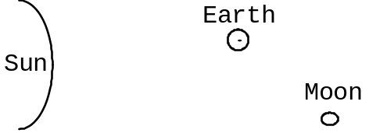
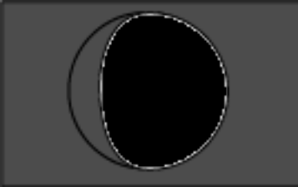
Waxing Gibbous
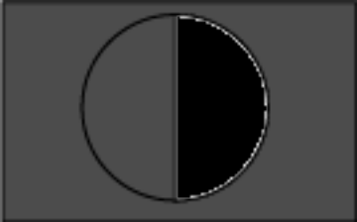
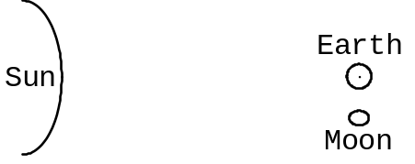
1st Quarter

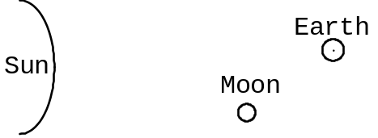
Waxing Crescent
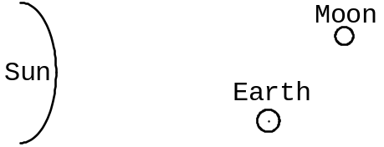
Waning Gibbous
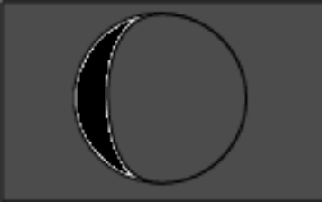
Waning Crescent

2. Questions about the photograph on the front cover of the course packet.
a. Why did the Earth look like a lop-sided football instead of a full circle?

The Earth was “gibbous” because the moon and Earth were not perfectly in line with the sun.

b. What were the relative positions of the sun, Earth and moon on December 22, 1968?

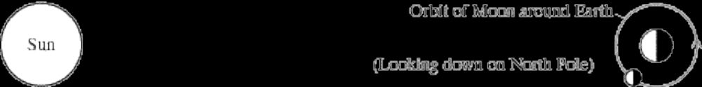
c. On that same day (December 22, 1968), what did the moon look like from Earth (i.e. what was the phase of the moon?)

The moon was in waxing crescent phase.

d. Why is the South Pole “up?”

The photograph was taken from what looks to us in the northern hemisphere like the “bottom” of the moon. From there, when you look at Earth, the northern hemisphere of Earth is on the “bottom.”

e. From any one place on the moon, does Earth ever really “rise” or “set?”

No, it doesn't! The same side of the moon is always facing Earth

Part 5: Multiple Choice
1. d
2. c
3. b
4. a
5. e
6. c
7. b

So then why is it called a quarter moon? Because it’s 1/4 of the way around in its orbit.
By the way, the position of the sun on every other date has shifted over time as well. Your astrological “sign” is supposed to be determined by what constellation the sun appeared to be “in” on the day you were born. However, the astrological signs have not changed with the times (I was born on June 11. According to astrologers, I am a Gemini but the sun was in the center of Taurus when I was born). In light of these facts, what do you think about the validity of astrology? (You don't have to answer this question, just think about it).
This lab activity was modified from Activity A-3 of the chapter entitled “Our Moon's Phases and Eclipses” in The Universe at Your Fingertips: An Astronomy Activity and Resource Notebook: The Astronomical Society of the Pacific, San Francisco (1995).
A Styrofoam ball will not do; the ball must be opaque. We got our Polystyrene balls from Molecular Model Enterprises, 116 Swift St., P.O. Box 250, Edgerton, WI 53334, (608)884-9877. We got 3 inch diameter balls for $.45 each and 7/8 inch diameter balls for $.12 each.
In science, we can only rule out wrong answers; we cannot prove right answers. We can be very very confident that a particular answer is correct but we can never be absolutely 100% sure—this limitation is an inherent aspect of the scientific method.
The waxing phases of the moon are when the lit portion of the moon is getting bigger from one night (or day) to the next; the waning phases are when the lit portion of the moon is getting smaller each night (or day).
Darken the part of the moon that is not visible; leave the “lit” portion of the moon white.
Definitions of the phases: Full MoonThe moon is full when the side we see is 100% illuminated. A full moon looks like a perfect circle.New MoonThe moon is new when the side we see is dark. We cannot see a new moon at all.Crescent MoonA crescent moon is shaped like a crescent; a smaller proportion of the moon is illuminated than is the case during a quarter moon.Quarter MoonThe moon is called a quarter moon when it looks like a half circle.Gibbous MoonA gibbous moon is shaped like a lopsided football; a larger proportion of the moon is illuminated than is the case during a quarter moon.Waxing MoonThe moon is waxing when the illuminated portion of the moon is getting a little bit bigger every day.Waning MoonThe moon is waning when the illuminated portion of the moon is getting a little bit smaller every day.
This lab activity was modified from Activity A-4 of the chapter entitled “Our Moon's Phases and Eclipses” in The Universe at Your Fingertips: An Astronomy Activity and Resource Notebook: The Astronomical Society of the Pacific, San Francisco (1995).
A solar eclipse happens during the day, when the sun is not visible at a time when it should be. A lunar eclipse happens at night, when the moon is not visible (or is VERY faint) when it should be very bright.
Note: the tiles in the room are exactly one foot square.
If we were to model the sun correctly to scale with this model Earth and moon, the sun would be 29 feet in diameter and located 1.2 miles away, as far from here as is the corner of 9th St. and Main St.
Note: Earth's orbit around the sun is nearly a perfect circle; it is off by only 4%. Astronomers have calculated the resulting difference in incoming solar radiation: it is only 7%.
For those who are curious, astronomers calculate these distances from the size of the sun as seen from Earth (objects look bigger when they're closer and smaller when they're farther away).
Source: Fraknoi, A. (ed.), 1995, The Universe at Your Fingertips: An Astronomy Activity and Resource Notebook: San Francisco, Astronomical Society of the Pacific. This is an EXCELLENT resource for teaching astronomy.
We will ignore the motion of the stars relative to each other and the effects of the precession (gradual change in orientation) of Earth's axis, both of which happen so slowly that no human being can live long enough to notice.
It is this movement that caught the attention of early astrologers who, perhaps understandably, concluded that it had profound spiritual significance.
The earth spins counterclockwise as seen from above the north pole. The earth orbits the sun counterclockwise as seen from above the sun's “north pole.”
You could make a lot of money by designing and selling a model celestial sphere with constellation names that read correctly when you are looking at the inside surface of the sphere.

